|  |
| --- |
| Hindware Home Innovation Limited* reported FY23 Consolidated Revenue from Operations of ₹2,873 crore, an increase of 25%, and EBITDA of ₹281 crore, an increase of 38%-Building Products Business EBITDA margins expand ~200 bps in Q4FY23 to 15%-, Registers highest-ever Sales (Revenues & Volumes) in Plastic Pipes & Fittings Business in FY23 |

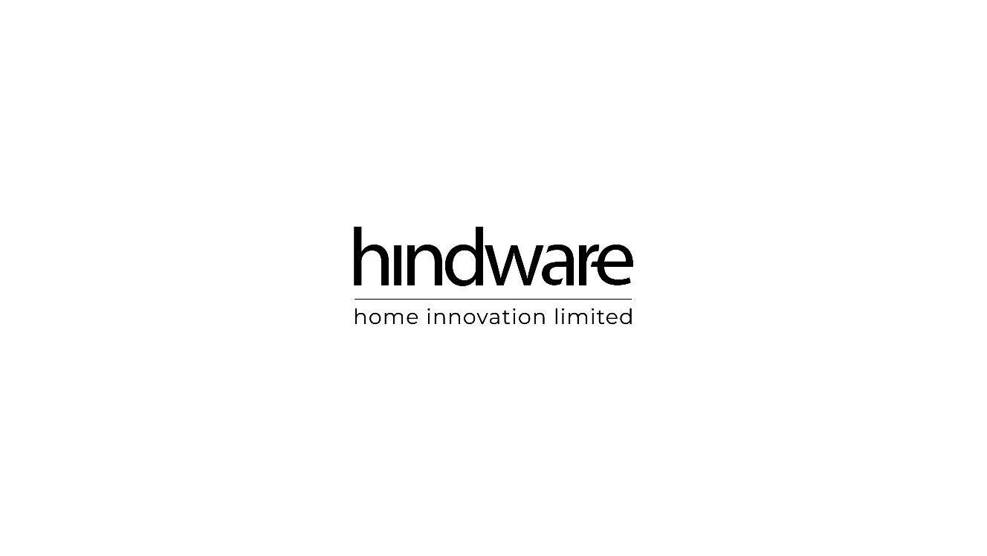

**Gurugram, 24th May 2023**: Hindware Home Innovation Limited (formerly Somany Home Innovation Limited), the Consumer Appliances and Building Products Company; today announced its financial results for the quarter and year ended March 31st, 2023.

The Company reported Consolidated Revenue from Operations at ₹2,873 crore, registering a growth of 25% in FY23. EBITDA expanded by 38% to ₹281 crore during FY23 as against ₹204 crore in FY22. In Q4FY23, Consolidated Revenue from Operations stood at ₹768 crore translating to an increase of 12% Y-o-Y, while EBITDA grew 33% Y-o-Y at ₹90 crore. Against the backdrop of an improving market environment and a strong focus on productivity and efficiency, there was a sequential growth of 8% in the topline and an expansion of 49% in EBITDA.

In FY23, the Consumer Appliances business maintained its revenue despite a challenging macroeconomic landscape resulting from higher inflation. In FY23 Revenue from Operations increased 16% over the previous year to ₹501 crore while EBITDA expanded by 42% to ₹25 crore. In Q4FY23, the Revenue from Operations and EBITDA amounted to ₹128 crore and ₹4 crore, respectively.

In FY23, the Building Products business which comprises Sanitaryware, Faucets, and Plastic Pipes & Fittings grew strongly by 29% over FY22 to ₹2316 crore with EBITDA expanding by 41% to ₹256 crore. In Q4FY23, the business reported ₹627 crore Revenue of Operations, higher by 14% on a Y-o-Y basis while EBITDA was ₹86 crore, registering a growth of 35% Y-o-Y. The Bathware business achieved industry-leading growth and margins on the back of an innovative product portfolio, enhanced brand awareness, diverse product range and strong distribution network. In addition, the business reaped the operating leverage benefits gained from the acquisition of the manufacturing facilities of AGI Greenpac.

The Company's Plastic Pipes and Fittings brand Truflo maintained its position as the fastest-growing in its segment. In FY23, the brand registered Revenue of Operations of ₹785 crore, a 29% increase over the previous year, and in Q4FY23, registered Revenue of Operations of ₹219 crore, growing by 7% Y-o-Y. This remarkable growth has been driven by a strong brand connection, increasing customer loyalty, and the successful launch of a second manufacturing plant.

**Commenting on the Company’s performance, Mr. Sandip Somany, Chairman, Hindware Home Innovation Limited* said,***“We have delivered a strong performance, despite inflation, elevated interest rates, and geopolitical uncertainties. We undertook several key initiatives to further strengthen our industry-leading growth in the sanitaryware and faucet segment and the results are visible. Our Plastic Pipes and Fittings business continues to be the fastest-growing brand in the segment and we anticipate exceeding our target of achieving ₹1,000 crore in sales before FY25.*

***He further added,****“Going forward, our focus will continue to be on innovation, expansion of our distribution, and enhancing our operating efficiencies and supply chain to generate reliable, sustainable shareholder returns.”*

**About Us:**

Hindware Home Innovation Limited (formerly Somany Home Innovation Limited) is the fastest growing player in Indian Consumer Appliances and a leader in the Building Products segment. The company is focused on servicing consumers and is involved in manufacturing, branding, marketing, sales & distribution, and service of various product categories.

The Consumer Appliances business consists of a selection of household appliances such as kitchen appliances: kitchen chimneys, cooker hoods, built-in hobs, cooktops, built-in ovens, and sinks. The business also houses water purifiers, air coolers, and ceiling fans. Hindware Home Innovation Limited also has a strategic marketing tie-up with a leading Italian company, Formenti & Giovenzana in the furniture and kitchen fittings segment. Hintastica Private Limited is a joint venture between Hindware Home Innovation Limited and Groupe Atlantic housing the manufacturing, marketing, and distribution of the water heater business under the brand Hindware Atlantic.

Hindware Home Innovation Limited through its wholly owned subsidiary (Hindware Limited) (formerly Brilloca Limited) has a versatile range of best-in-class sanitaryware, faucets, and tiles products with brands catering to a wide pricing spectrum of customers. Hindware Limited also houses the plastic pipes and fittings business under the brand Truflo by Hindware,’ one of the fastest growing brands in the country in this segment. ‘Truflo by Hindware’ also has a presence in overhead water storage tanks, column pipesand recently forayed into PTMT faucets & accessories to provide customers with a one-stop solution for all their plumbing requirements.

\**Formerly Somany Home Innovation Limited*

**For further information on the Company, please visit** [www.hindwarehomes.com](http://www.hindwarehomes.com) and [www.hindware.com](http://www.hindware.com)

**Meenakshi Oberoi: +91-986056994, meenakshi.oberoi@hindware.co.in**

**Naveen Malik** **Gavin Desa / Jenny Rose Kunnappally**

Hindware Home Innovation Limited CDR India

Tel: +91 124 477 9200 Tel: +91 98206 37649 / 91 86899 72124

Email: [Investor@shilgroup.com](mailto:Investor@shilgroup.com) Email: [gavin@cdr-india.com](mailto:gavin@cdr-india.com) /jenny@cdr-india.com